IFF ABK control unit ebay

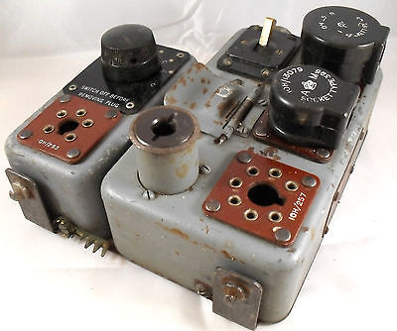
<style type="text/css">.vi-hide-mImgThr {display: none;}</style><img id="icImg" class="img img400" itemprop="image" src="http://i.ebayimg.com/t/WW2-RAF-AIRCRAFT-IFF-CONTROL-UNIT-TYPE-89-AND-90-SPITFIRE-LANCASTER-ETC-/00/s/MTMzN1gxNjAw/z/CasAAOxyVaBSrd9x/$_1.JPG" style="" clk="" />
Click to view larger image and other views

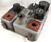

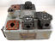

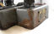

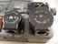

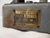

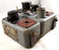

Have one to sell? Sell it yourself

Details about WW2 RAF AIRCRAFT IFF CONTROL UNIT TYPE 89 AND 90 SPITFIRE, LANCASTER ETC

| Add to watch list

Seller information
newp141 (691 )
100% Positive feedback
Follow this seller

See other items
AdChoice - opens in a new window or tab

Item Information
Item condition:
Used
“Light surface corrosion on the case (see photo)”
Time left:
2d 22h (Dec 22, 2013 09:10:49 PST)
Current bid:
GBP 77.00

Approximately US $126.22
[ 6 bids ]

Your max bid:
Place bid

Enter GBP 79.00 or more

Add to watch list
Add to collection
100% positiveFeedback

Shipping:
GBP 22.50 (approx. US $36.88) Royal Mail Airmail (Small Packets) | See details
See details about international shipping here.

Item location:
ESSEX, United Kingdom

Ships to:
Americas, Europe, Asia, Australia

Delivery:
Varies for items shipped from an international location
Seller ships within 2 days after receiving cleared payment.

Payments:
, Money order/Cashiers check | See details

Returns:
No returns or exchanges, but item is covered by the eBay Money Back Guarantee - opens in a new window or tab.
Guarantee:
| Learn more
Get the item you ordered or get your money back.

Print - opens in a new window or tab | Report item - opens in a new window or tab
- Description
- Shipping and payments
eBay item number:
171196277526
Seller assumes all responsibility for this listing.
Last updated on Dec 15, 2013 10:32:13 PST View all revisions
Item specifics
Condition: | Used :
Seller Notes: | “Light surface corrosion on the case (see photo)”

Type: | IFF | Age: | Vintage

